**Assembly instructions**

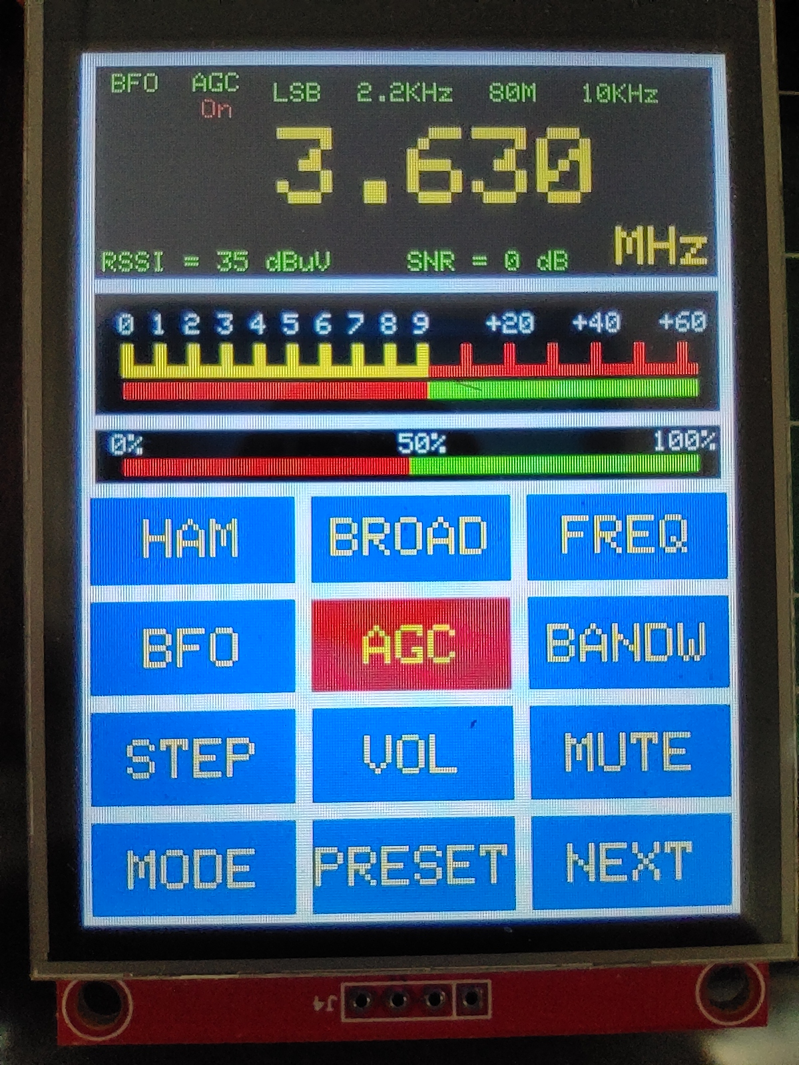

**Table of contents**

**INTRODUCTION……………………………………………………………….….. 3**

**ASSEMBLY INSTRUCTIONS………………………………………….…………. 4**

**SCHEMATICS………………………..…………………………………………….. 9**

**BILL OF MATERIALS……………………………………………………………… 11**

**USEFUL LINKS……………………………………………………………..………. 12**

**NOTES…………………………………………….………………………………….. 13**

**INTRODUCTION**

Gert, PE1MGB had been fascinated for some time by the different radio chips

from Silicon Labs Industries. The first chip with which he made an FM radio was the SI4703, specially developed for use in cell phones. With a small chip (3×3 mm),

These phones are equipped with a complete FM receiver including an antenna connection, RDS and a stereo AF output. Quality excellent and sensitivity not bad at all. The chip is controlled via a so-called I2C bus and is therefore easy to use in the Arduino world. Silicon Labs has developed many one chip radios over the years.

The use of radio ICs in the Arduino world stands or falls with the availability of a library. A few months ago he accidentally discovered the existence of a library made for the SI473x and SI474x series. These chips all use the same command set. Ricardo PU2CLR from Brazil has spent a large amount of time developing this library. The library is focused on and maximally tested for the SI4735. Here also the control of the chip is done via the I2C bus. The SI4735 is a true all band receiver from 150 kHz to 30 MHz and includes also FM. The specifications mention an upper limit of 26MHz, but in practice frequencies up to 30 MHz still work fine. So this chip is a receiver with FM, LW, MW and the entire short wave band. Furthermore, a patch is available that even allows SSB reception. A patch is a piece of software that in this case is additionally loaded into the chip for SSB reception. This patch is loaded via the I2C every time you switch to SSB mode. In addition, FM reception is also possible in Stereo and with RDS.

PU2CLR has developed a number of test programs to test the software on different platforms. A lot of buttons and different displays are used for this, but Gert found that not

very useful for a user device. He came up with the idea to continue with a large display and touchscreen. The choice was made for a 2.8 inch display with touchscreen.

Long story short, Gert spent many hours writing a sketch with the end result being a very attractive and easy to use GUI (graphical user interface) which made serving this radio chip a real pleasure. Gert still mentions the many tips he received from Robert, PA2RDK, who taught him how to set up the software in a tightly structured way. The whole story how this process started and ended can be read in the Razzies dated September 2020.

To simplify the reproduction of the project, PA3CNO designed a PCB, PA2RDK ordered the PCBs and, together with PA3CNO, they took care of the order- and shipment procedure.

Have fun building and using this special versatile “low cost” receiver.



Pictures say more than words. The number of parts to be assembled are limited, so the description will consist of a few images with accompanying tips.

**Assembly: SI 4732 / SI 4735**You may have ordered the PCB with the pre-mounted chip. In that case, you can skip this step.

When installing the chip, pay close attention to the position of pin 1.

I prefer to apply some solder flux. This facilitates soldering and flow of the solder. Apply the solder generously and after it has cooled down, remove the solder bridges between the legs with de-soldering braid. Check for shorts between the legs of the IC with an ohm meter.

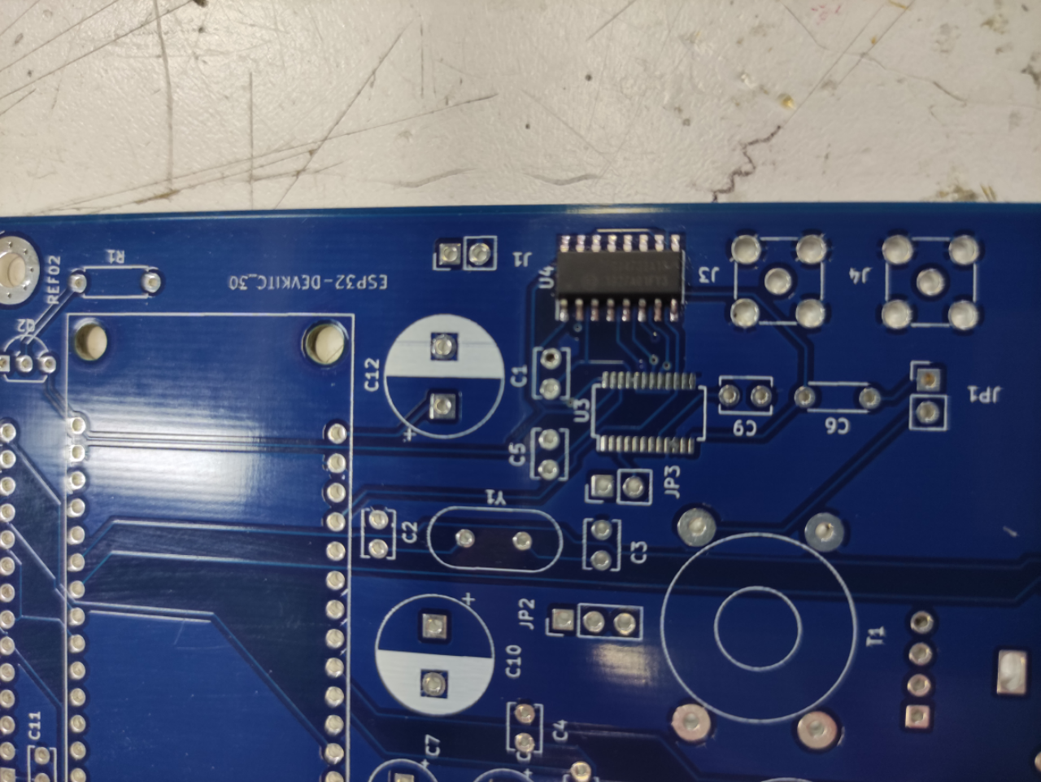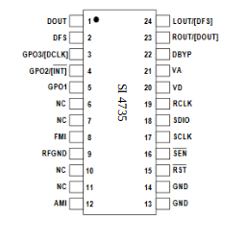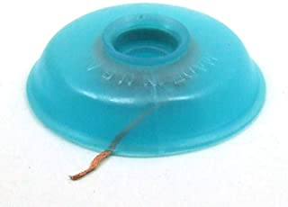

**Pin 1**

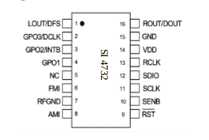

**Install all resistors**

Install R1, 2, 3, 4, 5, 6, 7, 8, 9 en 10

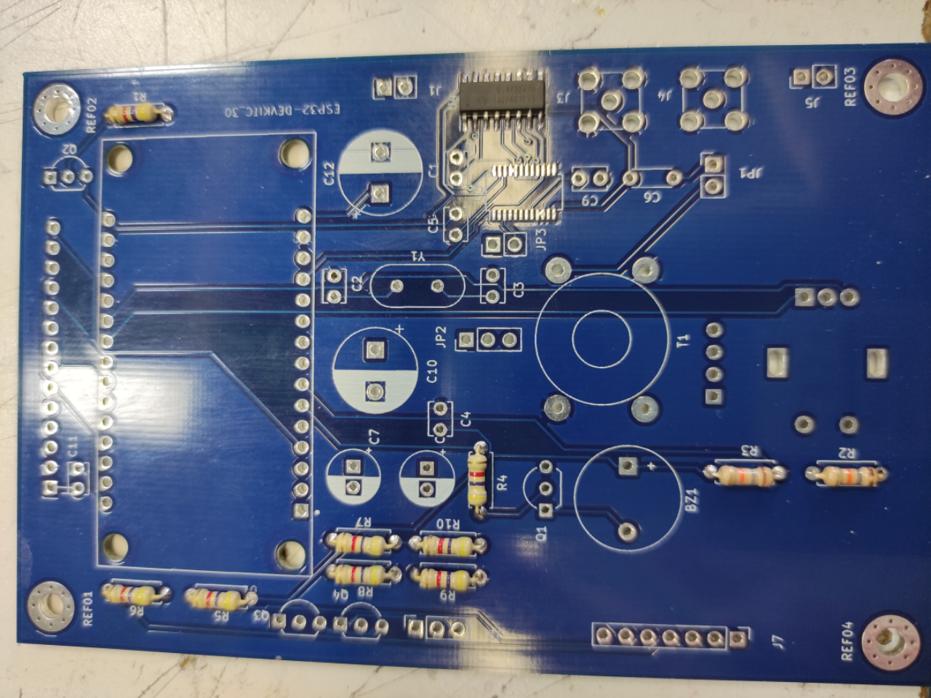

**Install the transistors**

Install Q1, 2 , 3 and 4

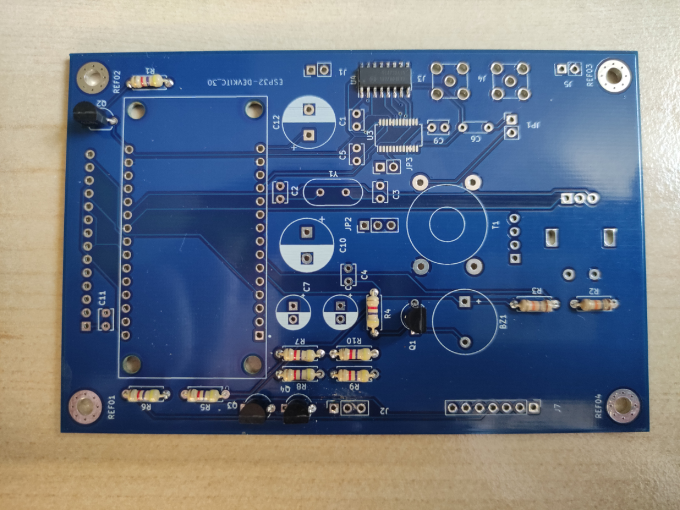

**Install the capacitors and headers**

Install C1, C2, C3, C4, C6, C9 en C11.  
Install JP1 en JP2.

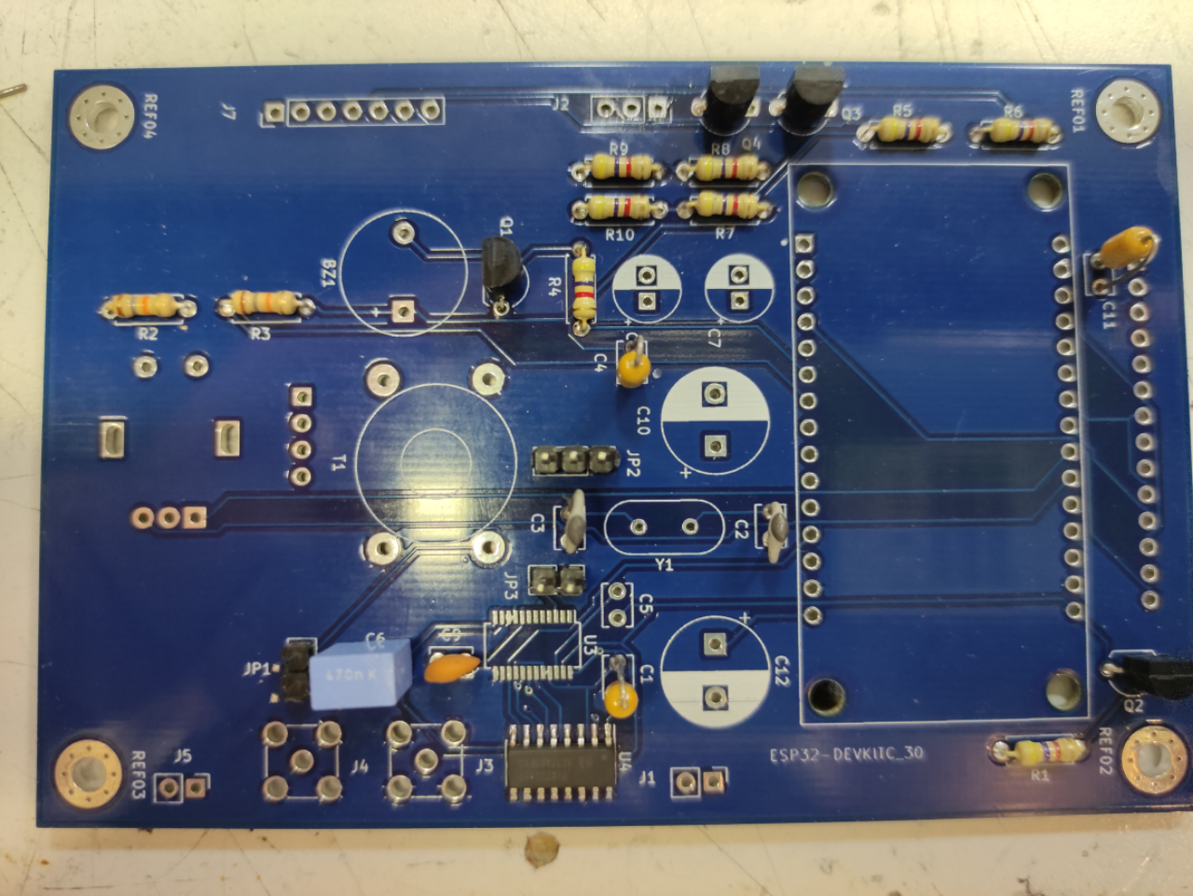

**Install the xtal, the electrolytic capacitors, headers, SMA connectors, the buzzer, the ESP32 and the jumpers**

Install the crystal. Install C5, C7, C10 en C12. Install the header J 7 and jumpers JP7 and JP3. Install the SMA connectors and the buzzer.  
Position two female headers on the ESP32 male connectors. Position the combination on the PCB and solder the male headers.

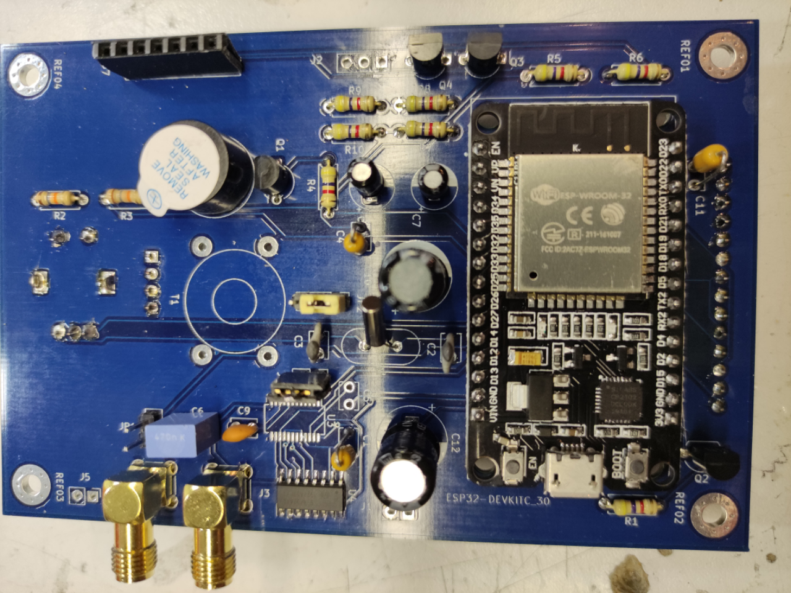

**The TFT display**

Solder a 4 pin male header on the TFT display. Then place a 14 pin and a 4 pin female header on the two male headers. Position the combination at the back of the print and solder the headers on the front side of the print.

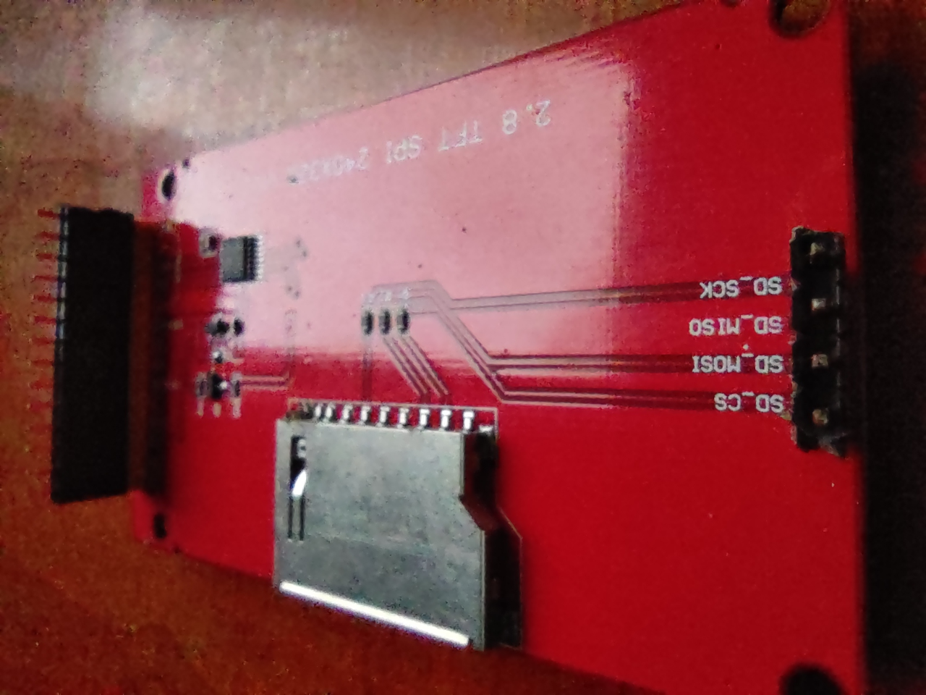

**The rotary encoder**

Install and solder the rotary encoder on the backside of the PCB.

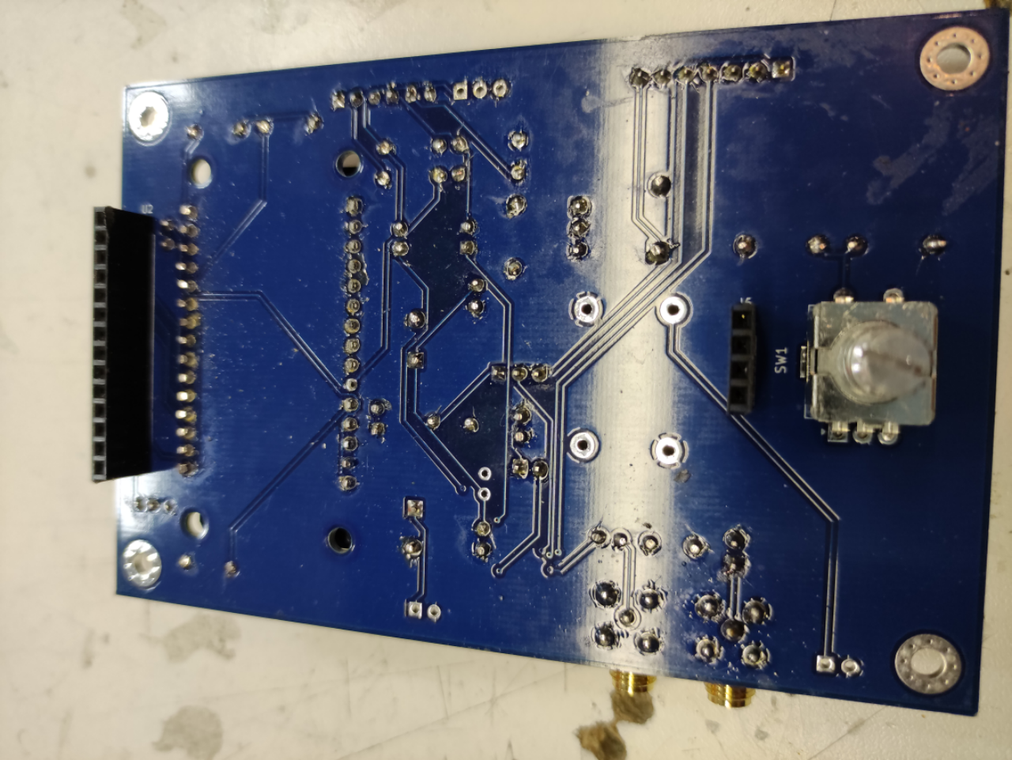

**The step-up transformer**Wind T1, 10 winding's bifilair, primary en 50 winding's secondary.  
Install T1

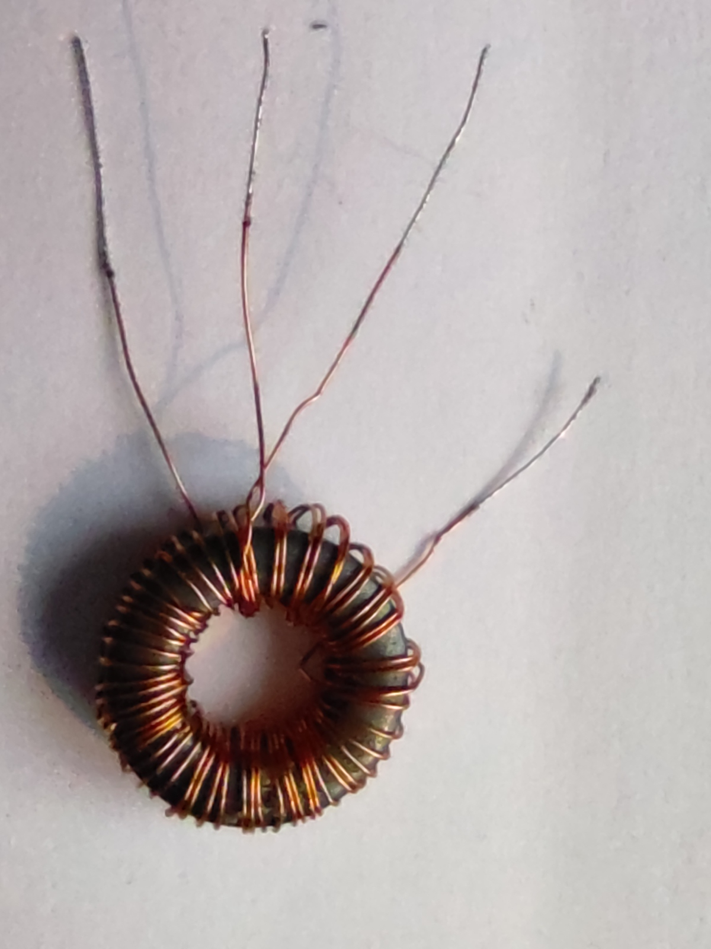

**FT 50-43**

**Schematics SI4732**

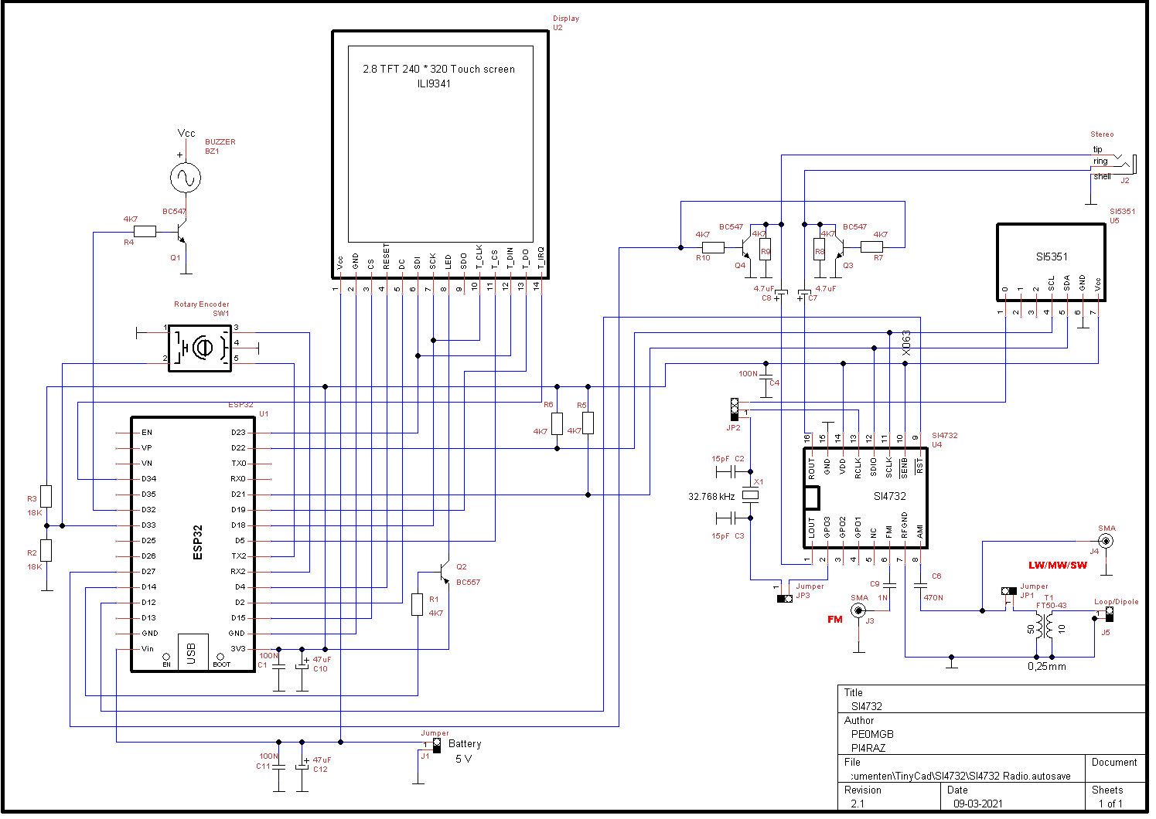

**Schematics SI4735**

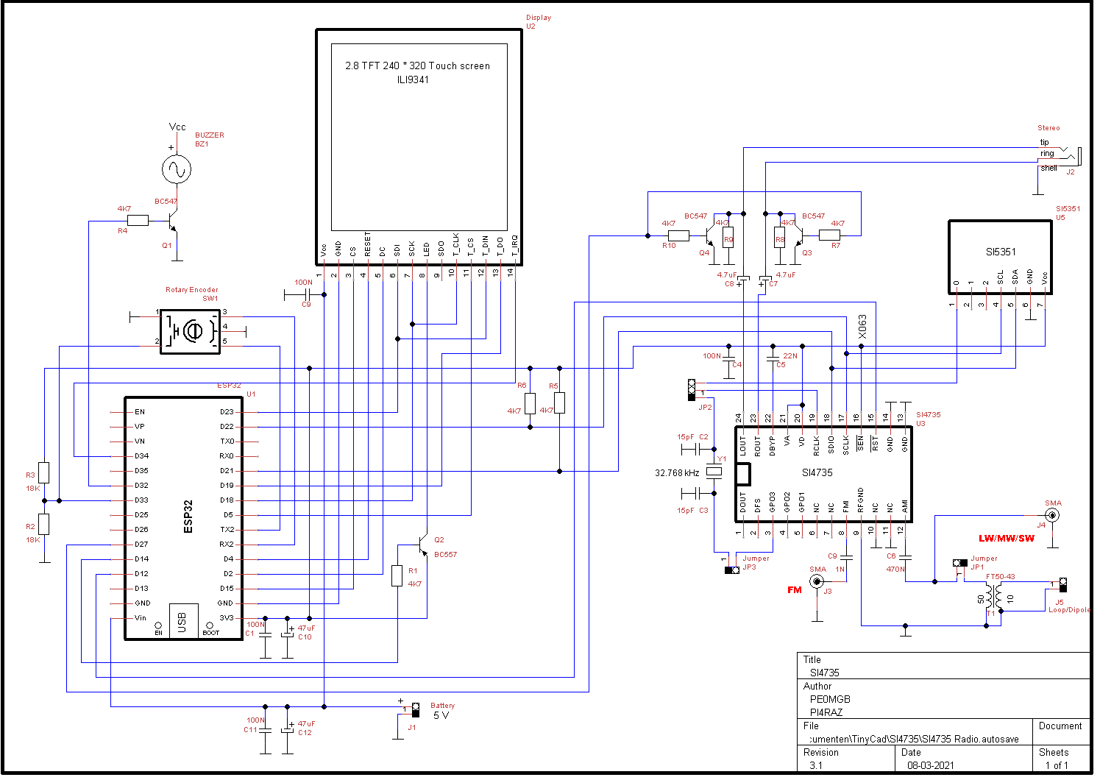

**Bill Of Materials**

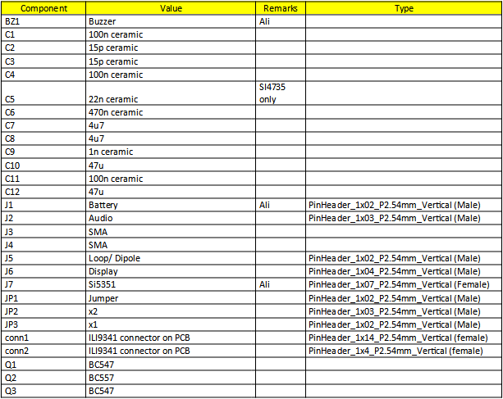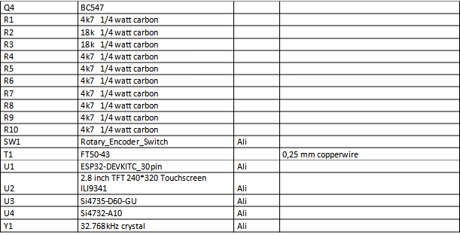

**Useful Links**

GitHub site **PE0MGB**: [https://github/pe0mgb/SI4735-Radio-ESP32-Touchscreen-Arduino](https://github.com/pe0mgb/SI4735-Radio-ESP32-Touchscreen-Arduino)  
  
GitHub site **PU2CLR**: <https://github.com/pu2clr/SI4735>

**Razzies** Sept 2020: <https://www.pi4raz.nl/razzies/>

**SI4735** chip: <http://s.click.aliexpress.com/e/_dUxdADh>

**ILI9341** Touch Screen: <http://s.click.aliexpress.com/e/_d7MMyNZ>

SI4735 Radio   
Experiments   
Facebook Group: <https://www.facebook.com/groups/532613604253401/>

**Notes:**